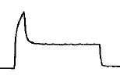
Schematic of ventilator waveform for a patient with high airway pressures secondary to high airway resistance. Adapted from Blanch, L. Respir Care 2005;50(1):110 –123

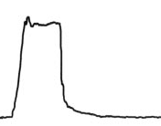
Schematic of ventilator waveform for a patient with high airway pressures secondary to decreased respiratory system compliance. Adapted from Bigatello, L. Respir Care 2005; 50(2):235–244

